Project Title: Sales & Profitability Dashboard

Problem Statement: Question: Which car brands and models generate the highest sales and profits across different countries and years?

• KPIs: Total Sales, Profit (SalePrice - CostPrice), Discount

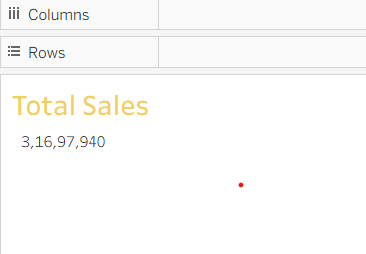

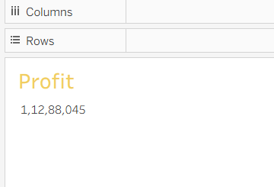

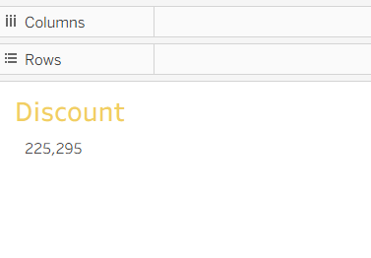
- Country-wise Sales
→ Which countries generate the highest sales revenue?

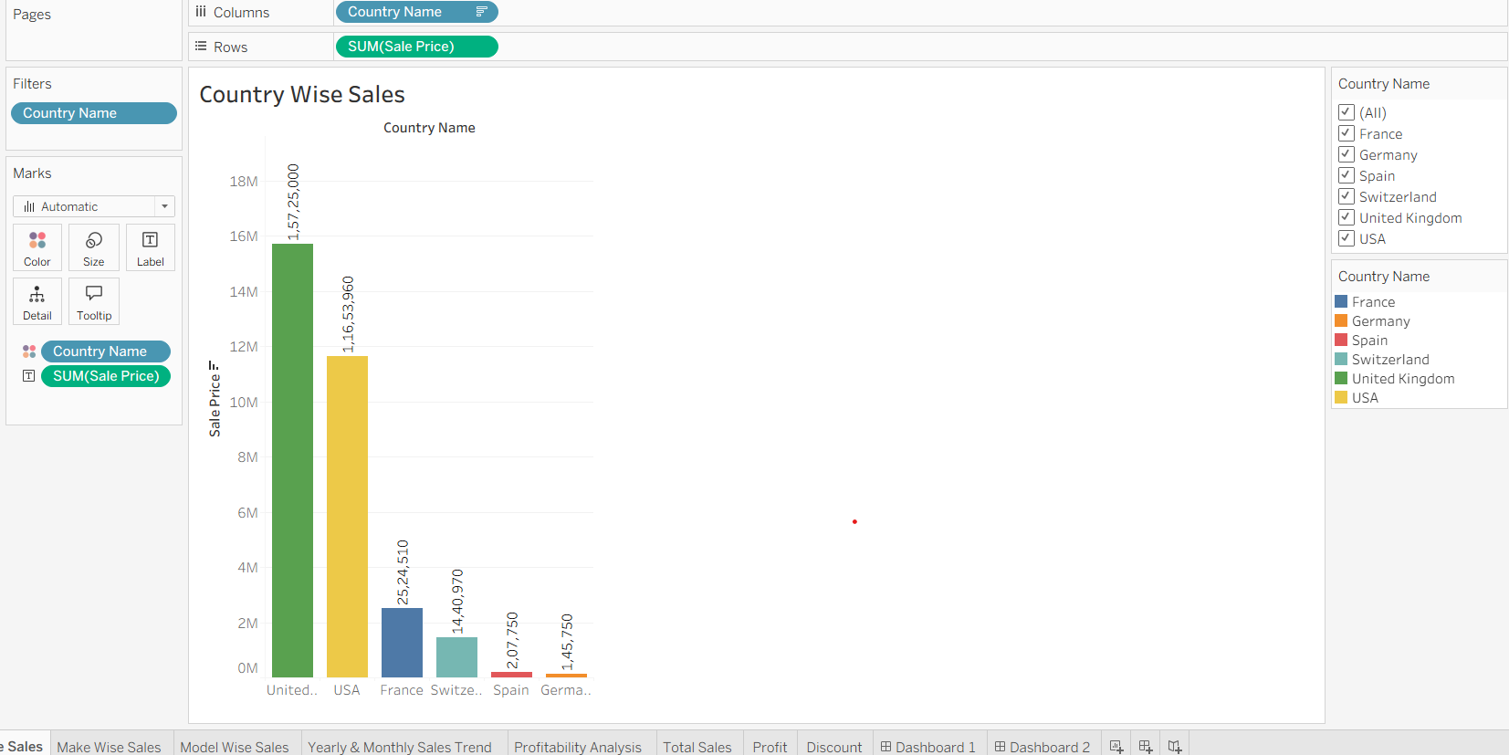

- Make-wise Sales
→ Which car brands (Make) have the highest sales?

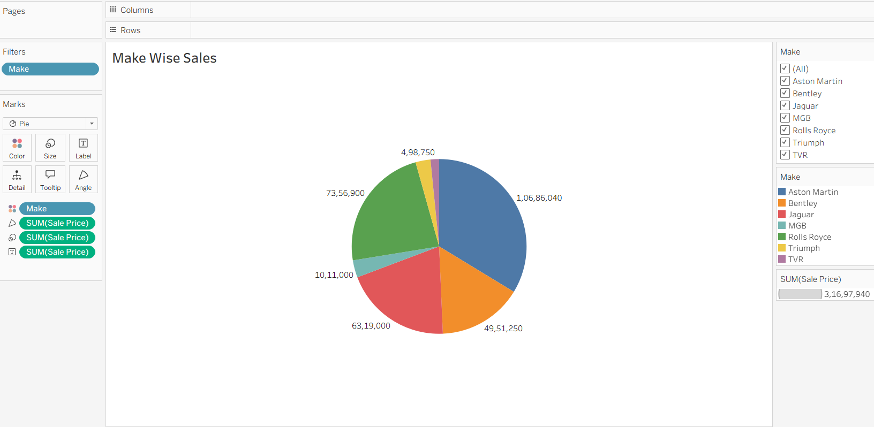

- Model-wise Sales
→ Which car models are most popular among customers?

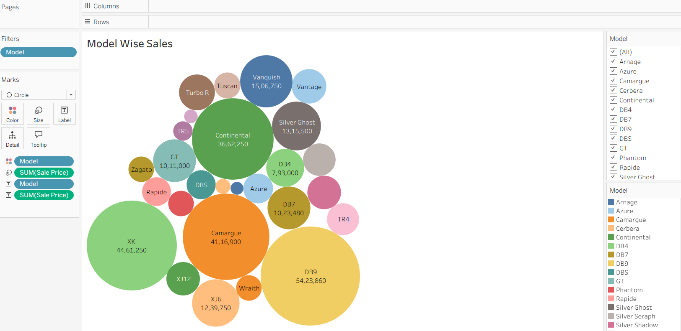

- Yearly & Monthly Sales Trend
→ How have sales changed year by year and month by month?
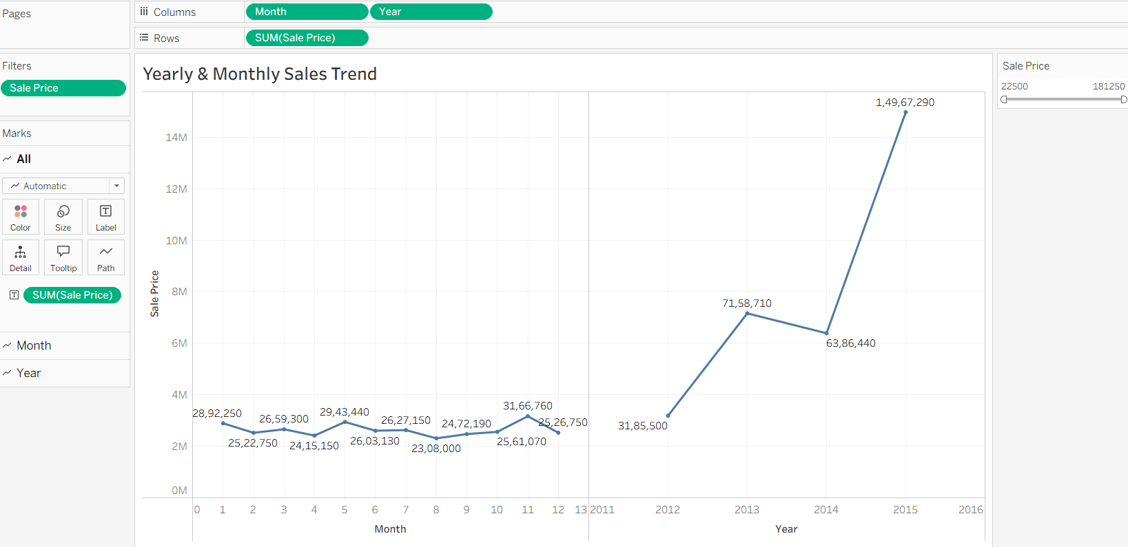

- Profitability Analysis
→ Which brands, models, or countries generate the highest profit (SalePrice – CostPrice)?
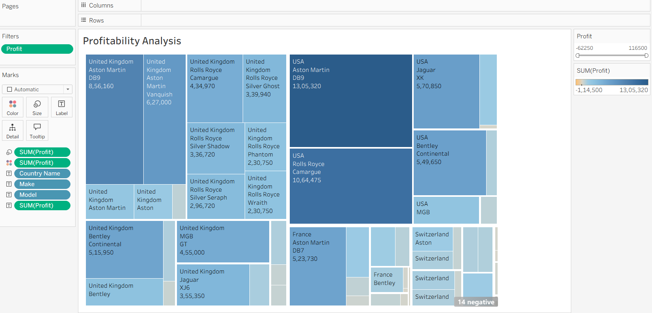

DASHBOARD

